# Appendices

## A graph of different colored lines Description automatically generatedPayoff Trial-level Plots

## Switching Trial-level Plots

## Response Times Trial-level Plots

## Cooperation/Competition – Lottery Deltas

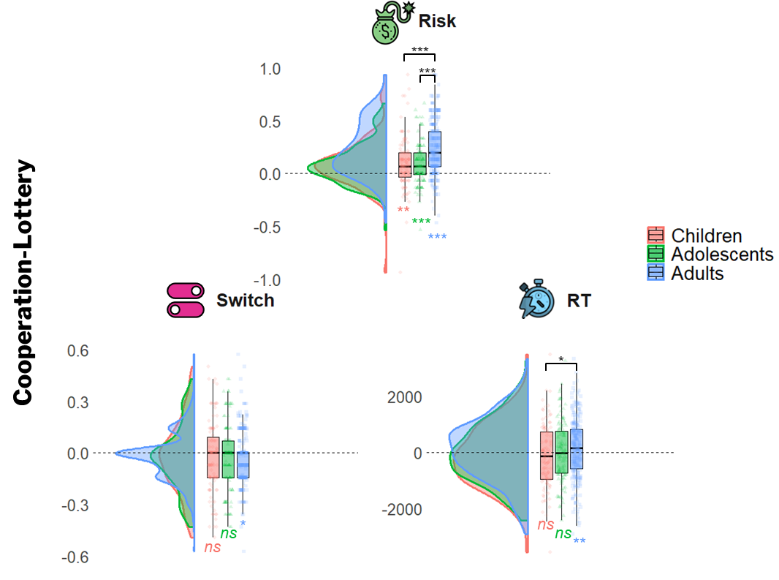

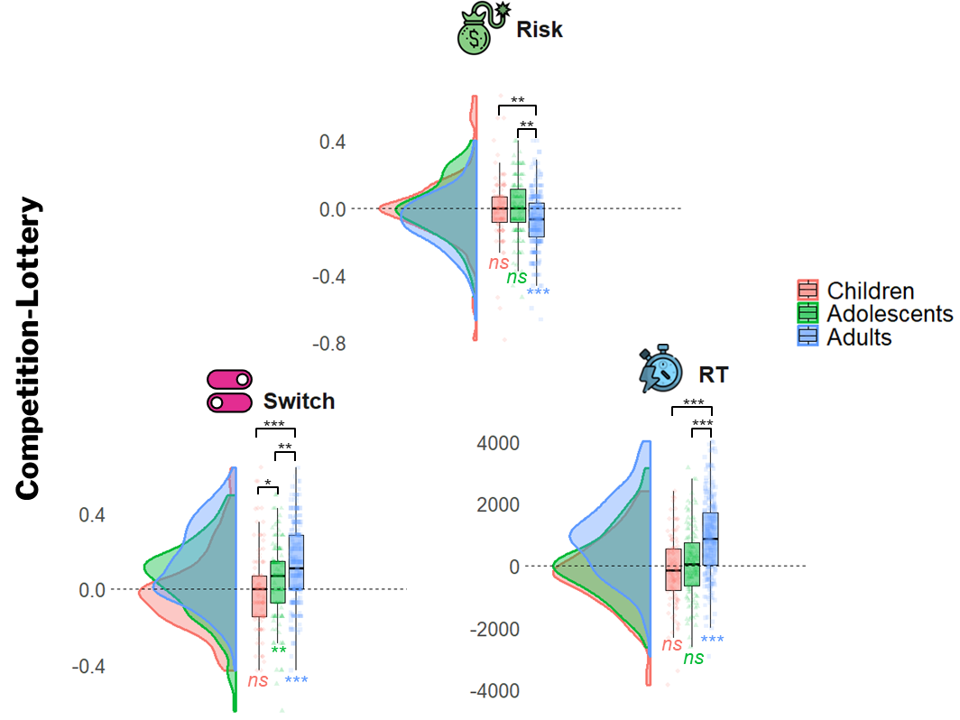

## A group of graphs showing different types of graphs Description automatically generated with medium confidencePredictors Correlations and Flags Table

|  |  |  |  |  |  |
| --- | --- | --- | --- | --- | --- |
|  | **Flag Type** |  | **Flagged Participants in Lottery** | | |
|  |  |  | Children | Adolescents | Adults |
| **N° of Flags** | No Switch |  | 10 | 5 | 10 |
| Slope |  | 29 | 18 | 10 |
| Total Flags |  | 39 | 23 | 20 |